**Url for Azure DevOps**

**Screenshots of azure boards**

**Screenshots of website**

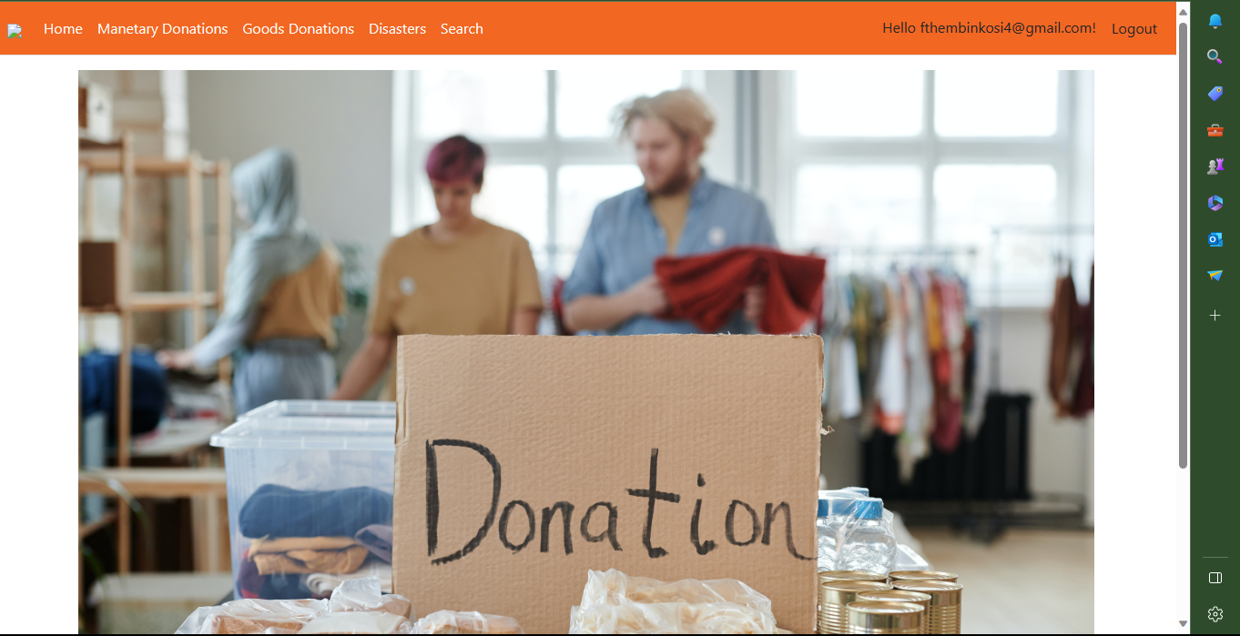

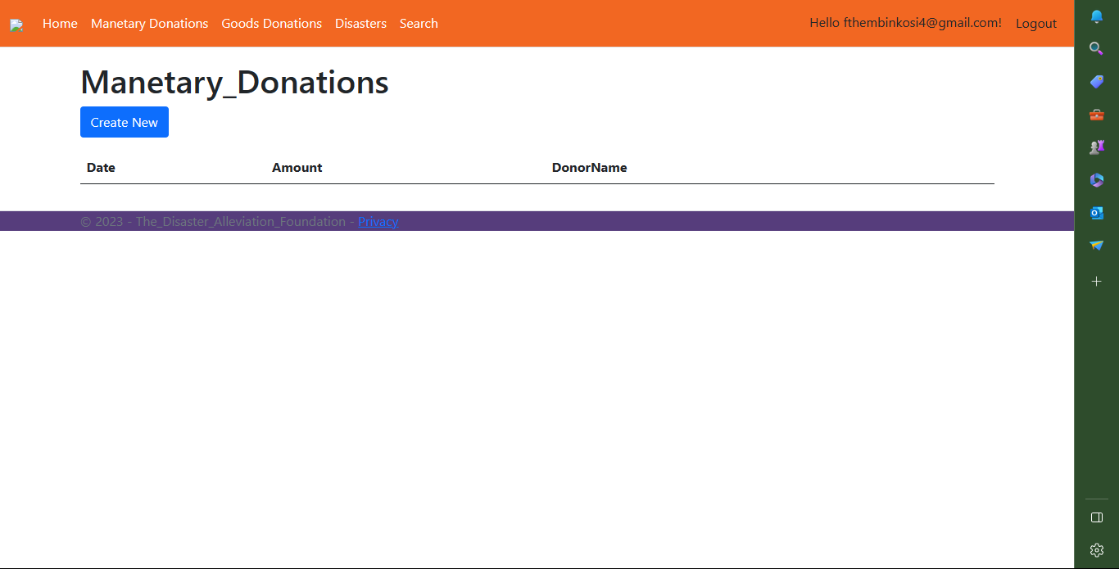

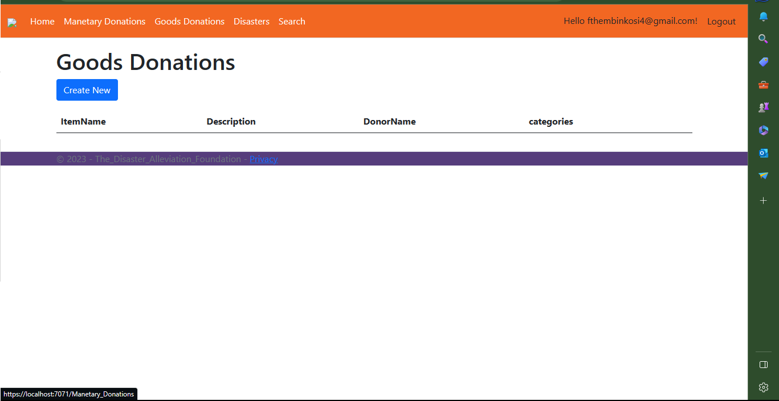

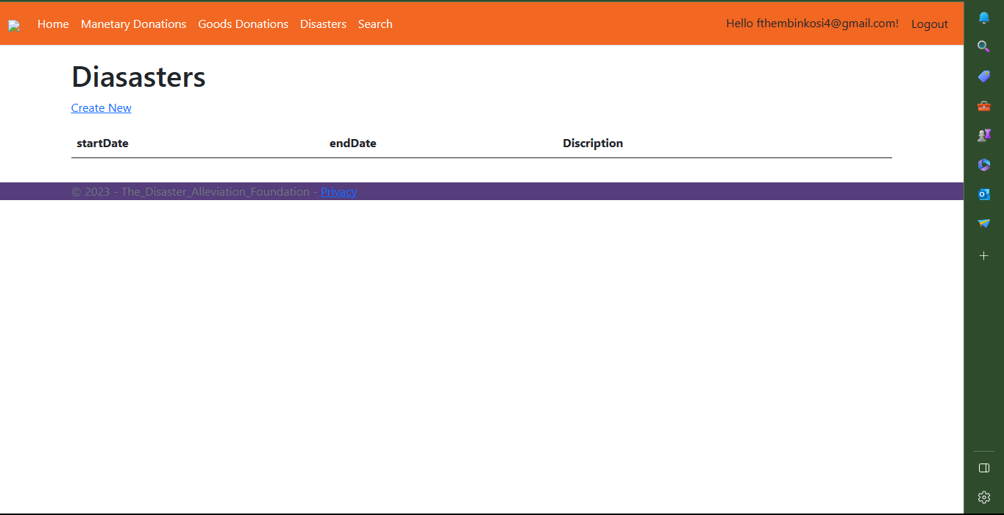

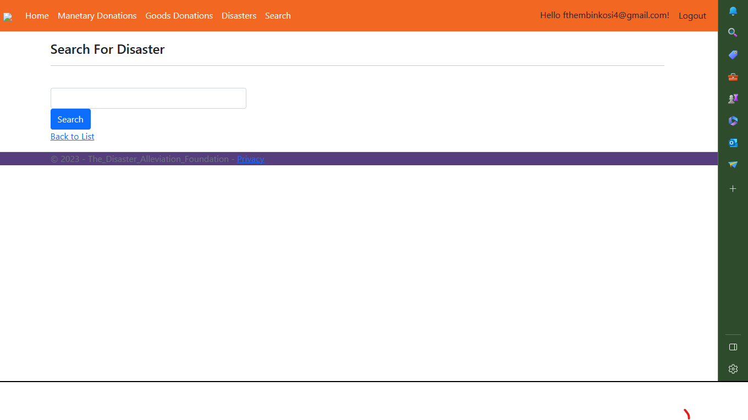

**Configuration**

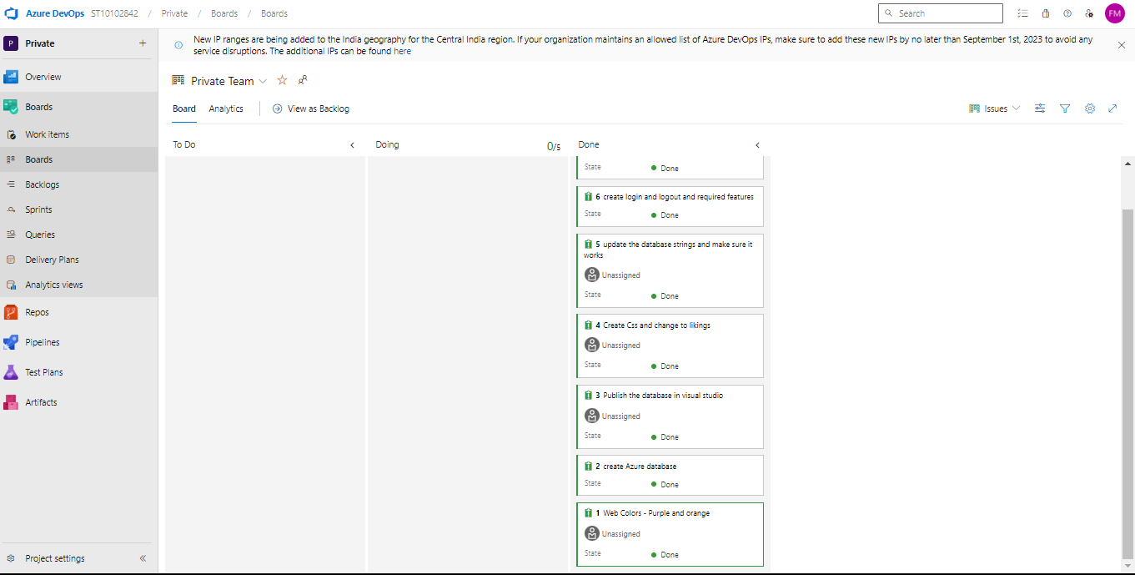

**url for deployed web application and login details**

thedisasteralleviationfoundation20230922172637.azurewebsites.net

ST10102842

Dosetime56

**Video**

**https://www.loom.com/share/0f1e53f2dcd14429a266279a131e144c**